

DRUG ACCOUNTABILITY/ INVENTORY InterFACe

INSTALLATION GUIDE

Version 3.0
June 2003

PSA*3*26

Department of Veterans Affairs
VISTA System Design & Development

Table of Contents

VISTA Patch Software Installation Instructions 1
Installation of Executable Files 2
ECHO Software Modifications 3

<This page is intentionally left blank.>

VISTA Patch Software Installation Instructions

For all facilities installing PSA*3*26, Drug Accountability/Inventory Interface V. 3.0 users must be off the system while installing the package.

Note: It is recommended that PSA*3*26 be installed during non-peak hours.

- DUZ must be defined and valid, and DUZ(0) must be equal to “@” before installing the software.

- Install patch PSA*3*26 following the example displayed below:

Example: Install Process

Select Installation Option: INstall Package(s)
Select INSTALL NAME: PSA*3.0*26 Loaded from Distribution 6/6/03@08:15:14
=> PSA*3*26 TEST v6

This Distribution was loaded on Jun 06, 2003@08:15:14 with header of
PSA*3*26 TEST v6
It consisted of the following Install(s):
PSA*3.0*26
Checking Install for Package PSA*3.0*26

Install Questions for PSA*3.0*26

Want KIDS to Rebuild Menu Trees Upon Completion of Install? YES// NO

Want KIDS to INHIBIT LOGONs during the install? YES// NO
Want to DISABLE Scheduled Options, Menu Options, and Protocols? YES// NO

Enter the Device you want to print the Install messages.
You can queue the install by enter a 'Q' at the device prompt.
Enter a '^' to abort the install.

DEVICE: HOME// GENERIC INCOMING TELNET

Install Started for PSA*3.0*26 :
Jun 06, 2003@08:16:02

Build Distribution Date: Apr 29, 2003

Installing Routines

Installing PACKAGE COMPONENTS:

Installing REMOTE PROCEDURE

Installing OPTION
Jun 06, 2003@08:16:02

Updating Routine file...

-----------------------------------------report continues----------------------------------------

Example: Install Process (continued)

Updating KIDS files...

PSA*3.0*26 Installed.
Jun 06, 2003@08:16:03

Install Message sent # 87156

--------------------------------------------------------------------------------
[------------------------------------------------------------]
100% | 25 50 75 |
Complete [------------------------------------------------------------]

Install Completed

Note: The PSA GUI UPLOAD option must be assigned to users who will be performing the upload procedure. This menu should be assigned to their secondary menu.

Installation of Executable Files

The following steps are to be performed by the Information Resource Management (IRM) Staff on the Prime Vendor PC:

- Delete the old VACRC.EXE from the PC’s C: drive.
- Copy the executable files to the Prime Vendor PC’s C: drive.
- Create a desktop shortcut to the PSA_VENDOR_UPLOAD.EXE file.

ECHO Software Modifications

The ECHO software must be modified to use the net ordering capability. This section shows how to perform the changes.

- The AMERISOURCE supplied PC with ECHO Version 3.1.8 or greater installed needs to be networked (currently using Windows 2000) into the system.
- IRM should remove the MODEM from the AMERISOURCE PC. The modem should be given to the procurement person to be returned to AMERISOURCE.
- IRM will then install the GUI and security files to the C: Drive of this PC and create a desktop GUI link accessible by all users.

Note: Access is necessary on this PC to all network programs – the site browser with VISTA access, MS Office, etc. and ECHO for all users.

Example: Echo Modification

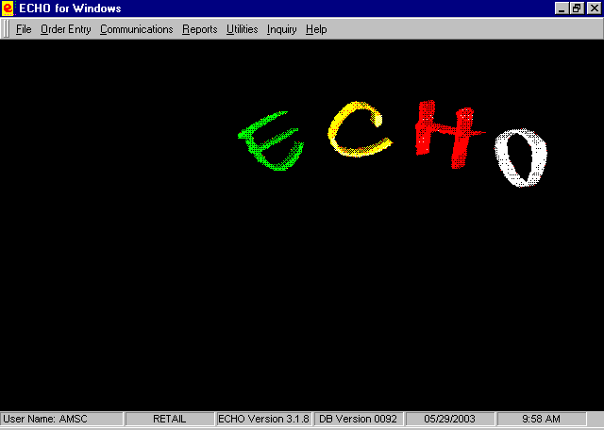
- In the ECHO program, click on the Utilities tab and then on Update customer record.
- Choose the tab Communication Setup: ZCOM IP Settings.
- Next press <Ctrl> <C> and enter ECHO as the password.

Example: ZCOM IP Settings Screen

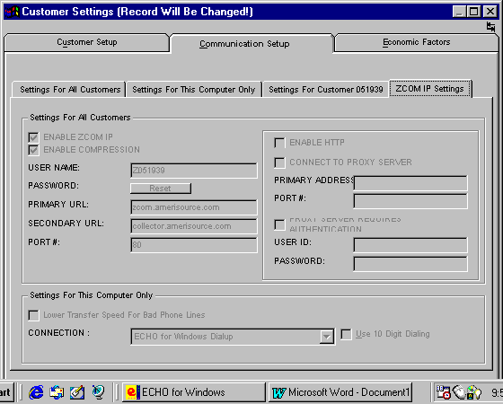

- On the right side of the screen: click and checkmark ENABLE HTTP and CONNECT TO PROXY SERVER.
- On the right side of the screen: Enter the PRIMARY ADDRESS: as Zcom.Amerisource.com
- On the right side of the screen: Enter the PORT #: as 80. The screen should look like the following screen example:

Example: ZCOM IP Settings Input

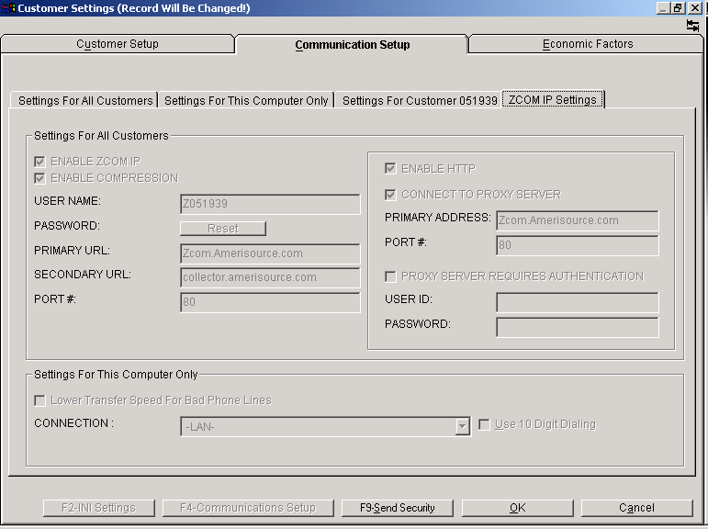

- Next click OK to end screen input.

The user should now be able to use Internet ordering just like it was when using the modem and phone line.

